**Aim**: Design WAN as per the given scenario and get the connectivity between all PCs using BGP

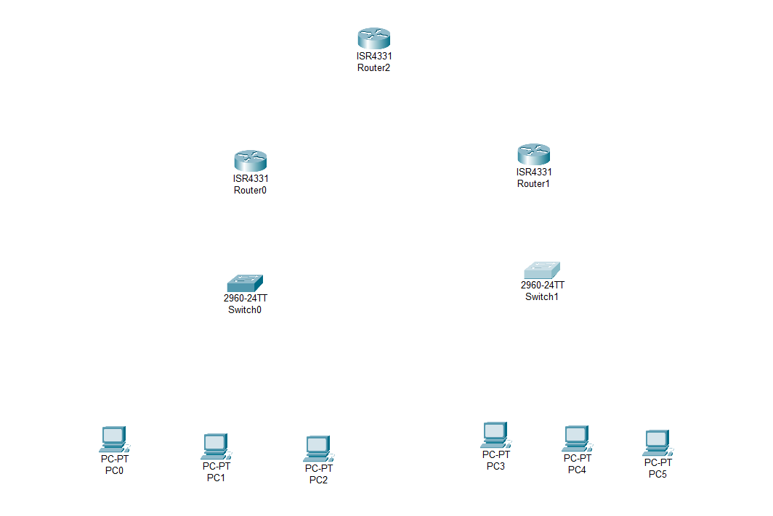**Step – 1:-** Open the Cisco Packet tracer and take three routers, two switch and six PC’s.

**Step – 2 :-**  To long distance communication we need to connect router using Serial DTE cable. For the serial port we have to open router turn off it and drag and drop WIC-1T on router and turn on router.

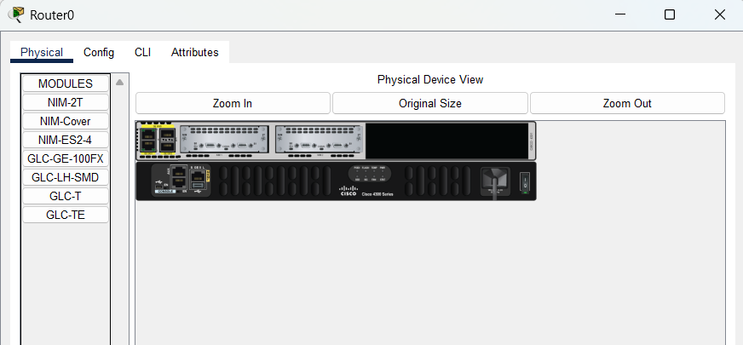

**Step – 3 :-**  Now Connect Two Routers Using Serial DTE Cable.

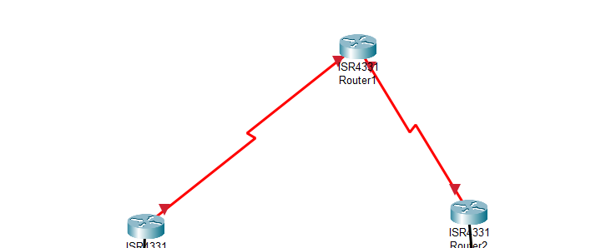

**Step – 4 :-**  Now Connect the Switches with routers using Copper Straight through cable In GigaEthernet Port.

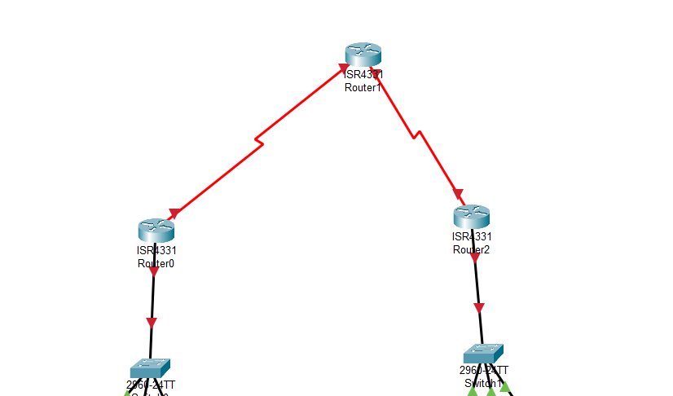

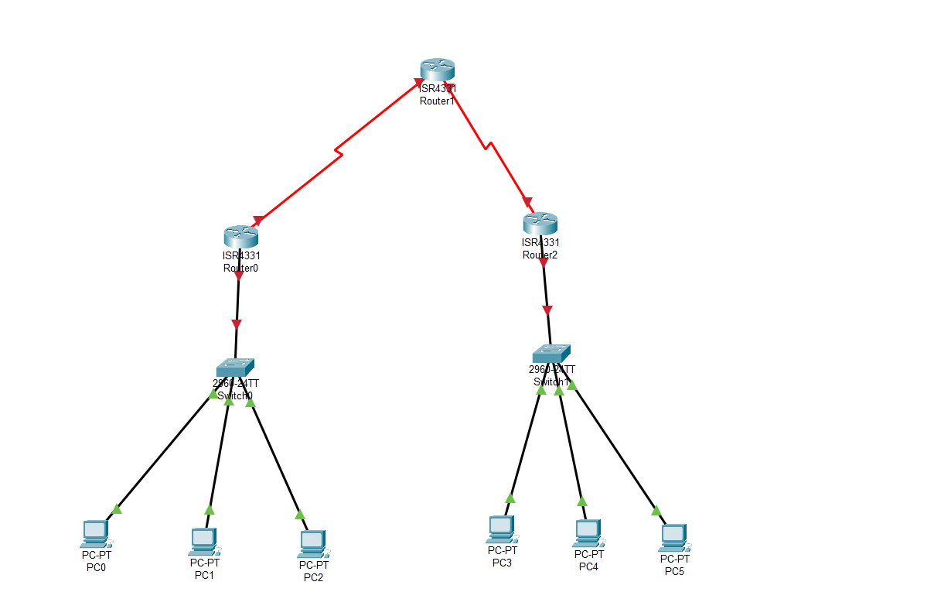**Step – 5 :-**  Now Connect PC’s with Switches using copper Straight through cable.

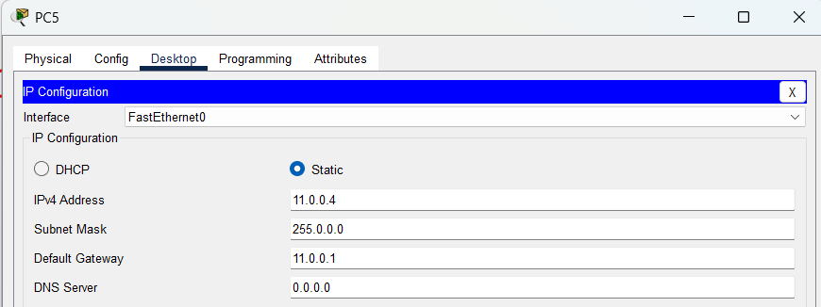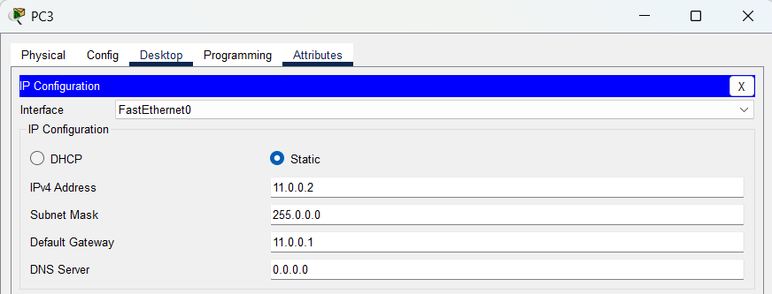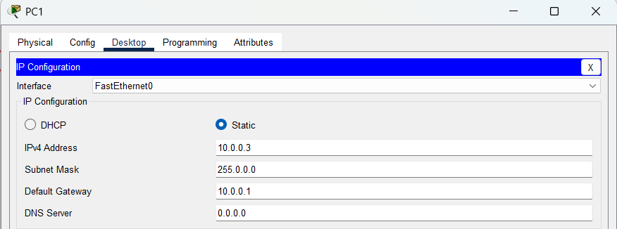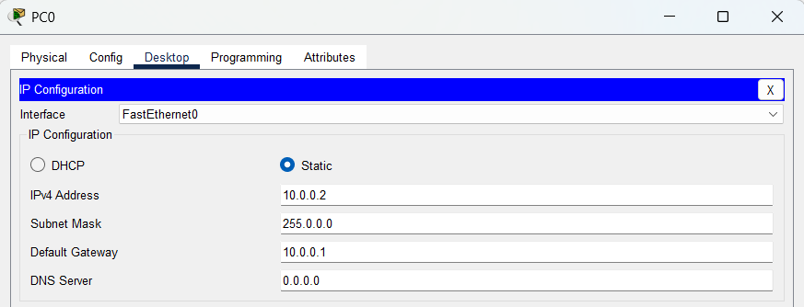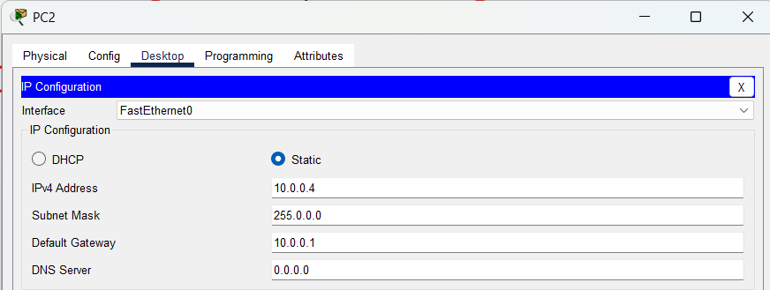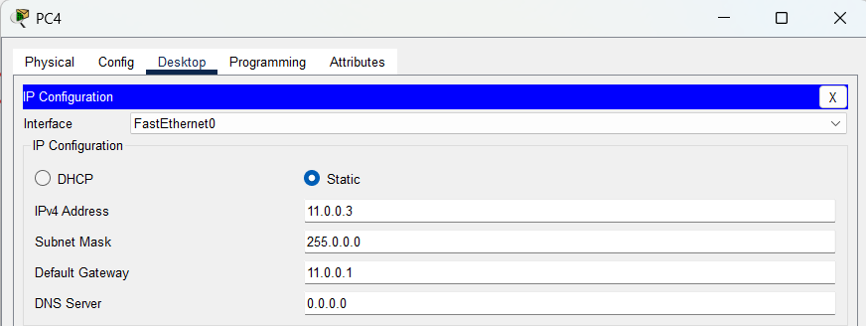**Step – 6:-**  Now assign the IP address And Subnet mask and Gateway to all PC’s.

**Step – 7 :-**  Assign IP Address to Routers

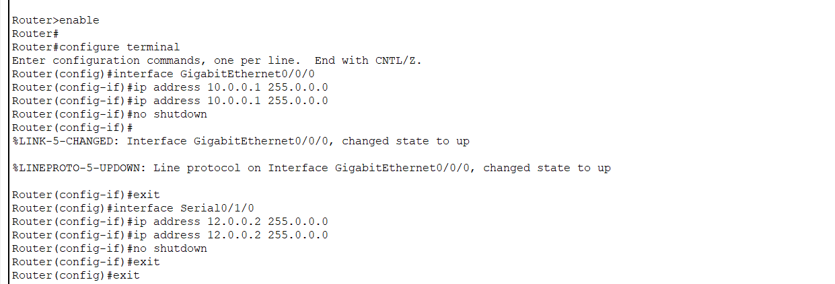Router – 0 :-

Router – 1 :-

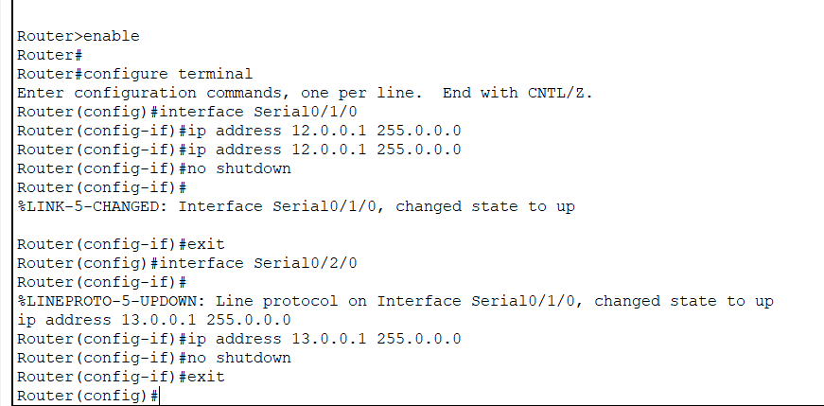

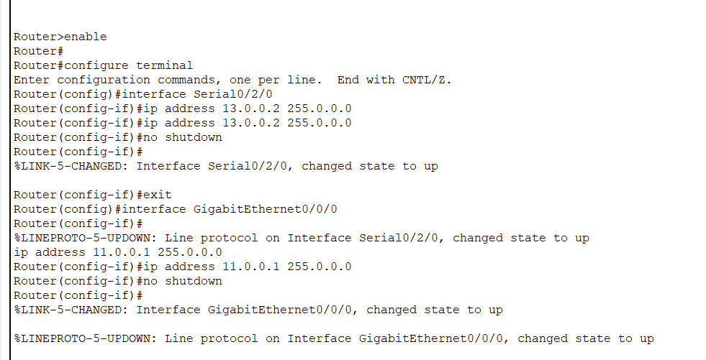Router – 2 :-

**Step – 8 :-**  now we will configure router for BGPP Protocol.

Router – 0

1. **router bgp 10**  
   This initializes a BGP process with AS number 10. This AS will be the local router's AS number.
2. **bgp router-id 1.1.1.1**  
   This sets the BGP router ID to 1.1.1.1. The router ID is a unique identifier for the router in the BGP network and is typically set to an IP address that is stable and does not change (like a loopback address).
3. **neighbor 12.0.0.1 remote-as 30**  
   This defines a BGP neighbor with IP 12.0.0.1 in AS 30. This means the router will establish a BGP session with a peer located in AS 30.
4. **network 10.0.0.0 mask 255.0.0.0**  
   This advertises the network 10.0.0.0/8 into the BGP routing table. BGP will only advertise this network if the router has an exact match for it in its routing table (e.g., from a static route or another routing protocol).
5. **network 12.0.0.0 mask 255.0.0.0**  
   This advertises the network 12.0.0.0/8 into the BGP routing table under the same conditions as above.

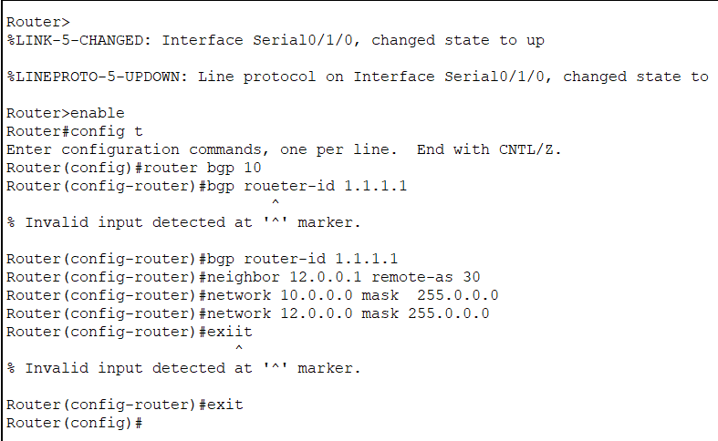

Router – 1 :-

1. **bgp router-id 3.3.3.3**

* This sets the BGP router ID to 3.3.3.3.
* The router ID is a unique 32-bit identifier, often set to a loopback IP address for stability.
* It doesn’t have to belong to a network advertised by BGP, but it should be unique within the BGP topology.

1. **neighbor 12.0.0.1 remote-as 10**

* Configures a BGP neighbor with IP 12.0.0.1 in AS 10.
* This establishes a BGP session with a peer that is part of the same AS as this router.

1. **neighbor 13.0.0.1 remote-as 20**

* Configures a BGP neighbor with IP 13.0.0.1 in AS 20.
* This establishes a BGP session with a peer in a different AS.

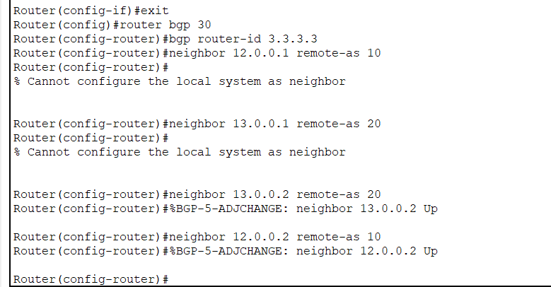

Router-2 :-

* 1. **router bgp 20**
* Starts the BGP process for Autonomous System (AS) 20.
* This defines the local router as part of AS 20.
  1. **bgp router-id 2.2.2.2**
* Sets the BGP router ID to 2.2.2.2.
* The router ID is a unique identifier (usually a loopback IP) for this BGP process.
  1. **neighbor 13.0.0.1 remote-as 30**
* Configures a neighbor with IP 13.0.0.1 in AS 30.
* This establishes an EBGP (External BGP) session between AS 20 and AS 30.
  1. **network 11.0.0.0 mask 255.0.0.0**
* Advertises the 11.0.0.0/8 network from the local routing table into BGP.
  1. **network 13.0.0.0 mask 255.0.0.0**
* Advertises the 13.0.0.0/8 network from the local routing table into BGP.

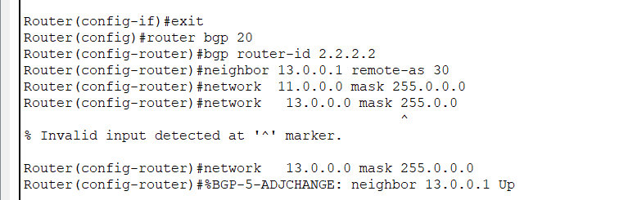

**Step – 9 :-**  now we will check the BGP Neighbour using the command **show ip bgp neighbor**

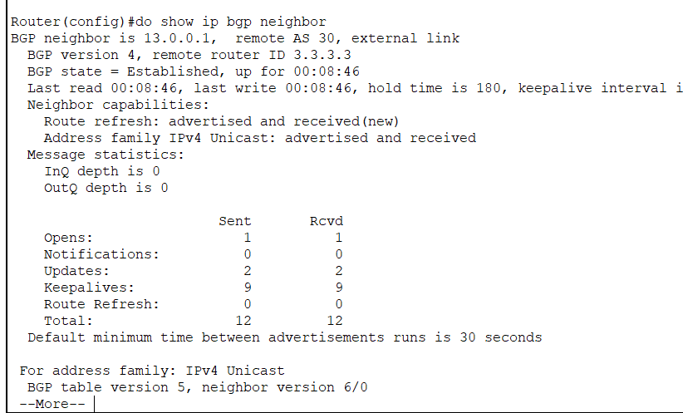

**Step – 10 :-** now we will check summary of bgp using the command **show ip bgp summary**

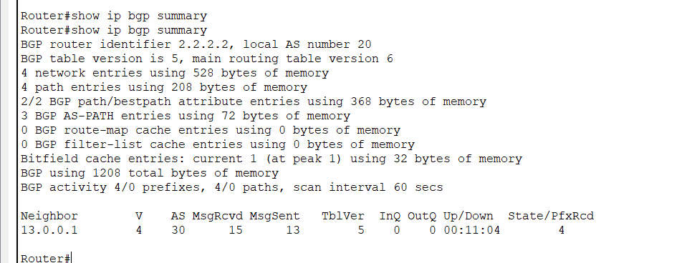

**Step – 11 :-**  now we will check the connection using the ping dest_ip command

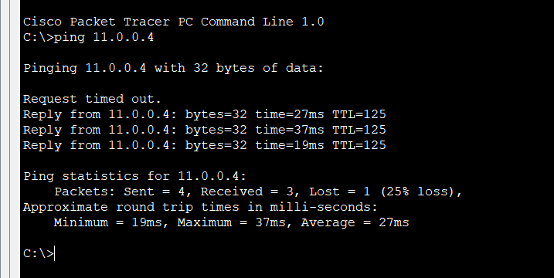

**Conclusion :-**

In this Experiment of BGP we connect all the PC’s using BGP Router from three Autonomous system AS 10 , AS 20 , AS 30. Every router has its unique id. AS10 was connected to AS30 via 12.0.0.1 and AS20 is connected to AS30 via 13.0.0.1. i learned the new commands bgp router id to give the id to the router neighbor 12.0.0.1 remote-as 30 to define the neighbour network 11.0.0.0 mask 255.0.0.0 Advertises the 11.0.0.0/8 network from the local routing table into BGP.show ip bgp neighbor to get all the neighbors and show ip bgp summary to get the summary.